Name of Student: __________Ali Wardah_______________

# Lab4: Difference Equations/Convolution

1. Jim opens an investment certificate today on his 30th birthday. He deposits $2000 at this time and on every birthday thereafter. In addition, he earns interest compounded annually. The table below shoes the rate of interest per year. Write a difference equation which calculates the amount he’ll have in his account by his 60th birthday. Write a brief computer program to calculate this amount. Hand in your code with the answer.





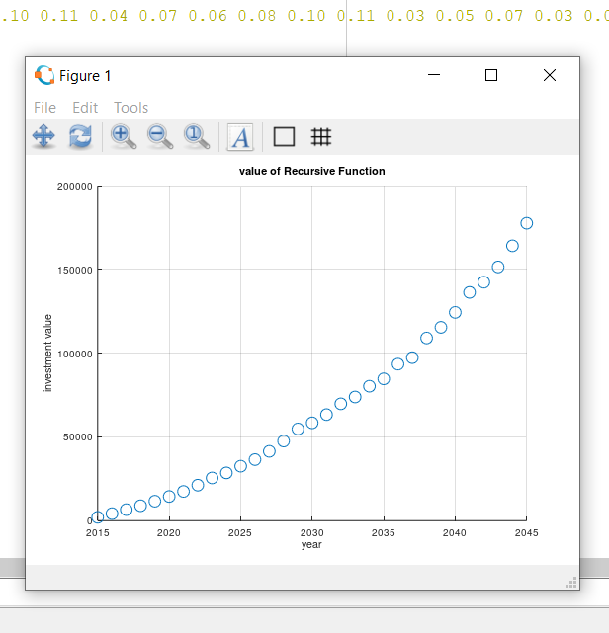

1. Consider the following running average filter. Write a MATLAB program that performs the following tasks.

where $x\left(k\right)=\sin\left(0.1πk\right)-2\cos\left(0.2πk\right)+3\sin\left(0.3πk\right), 0≤k<N$

Compute and plot the impulse response h(k) for 0 ≤ k < N where N = 50 from 1st principles. Now, use the functions *‘filter’* and *‘conv’* to arrive at the same results. This will require some research of the functions.

